Linux foundations with commands and files

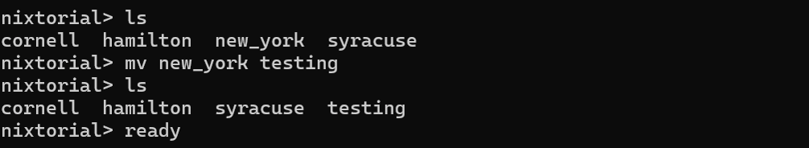
In this lab I used the ‘ls’ command and then renamed the file ‘new_york’ to ‘testing’

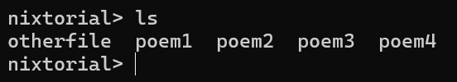
- I commanded ‘ls’ to list out what the current files were in that directory.
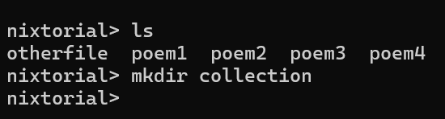
- I created a directory ‘collection’ to store just the poem files.
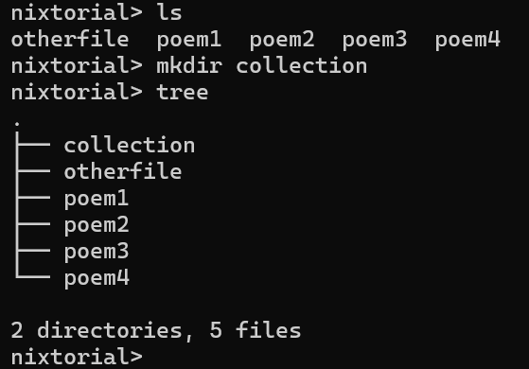
- I used the command ‘rm’ to remove the ‘otherfiles’ file from the collection directory.
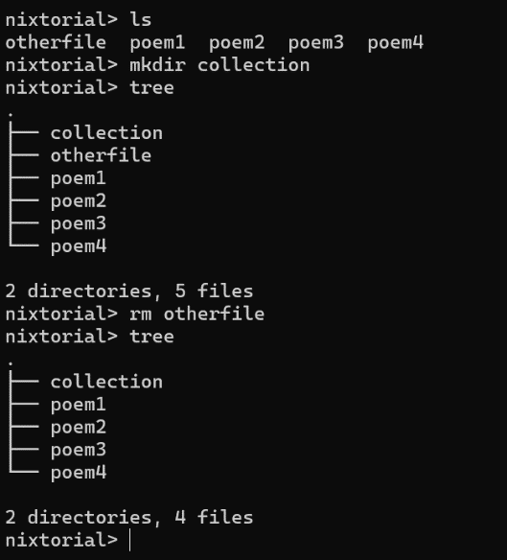
- Result
CP file to new folder:
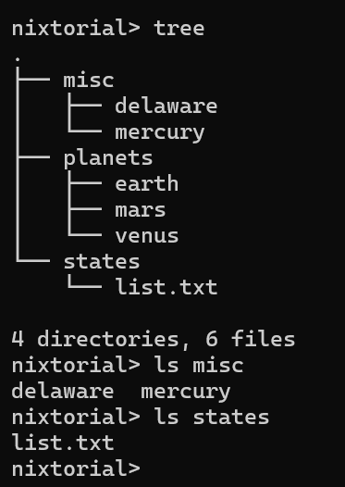
- For this lab the goal was to copy the file ‘delaware’ to the folder ‘states’ using the ‘cp’ command.
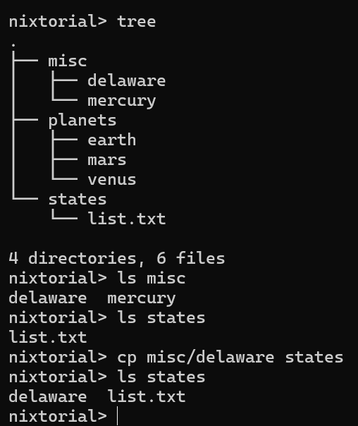
- Using the ‘ls’ command to confirm that the ‘delaware’ file is now in the ‘states’ folder.

Command ls -tr:
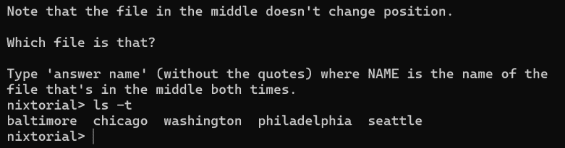
- For this lab I used the ‘ls’ command to view a list of states created from newest to oldest
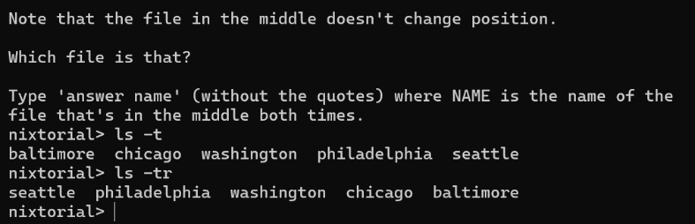
- I used the ‘r’ flag to reverse the order to identify which state still remained in the same position in order.
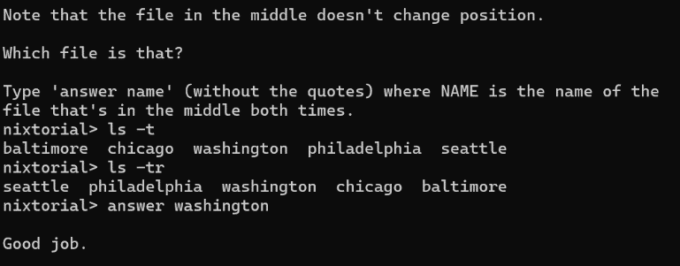
- The state that remains in the same position is ‘washington’
Moving a subfolder:
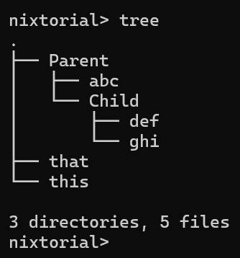

- For this lab I used the ‘cp’ command to separate the subfolder ‘Child’ out of the ‘Parent’ folder to the top.
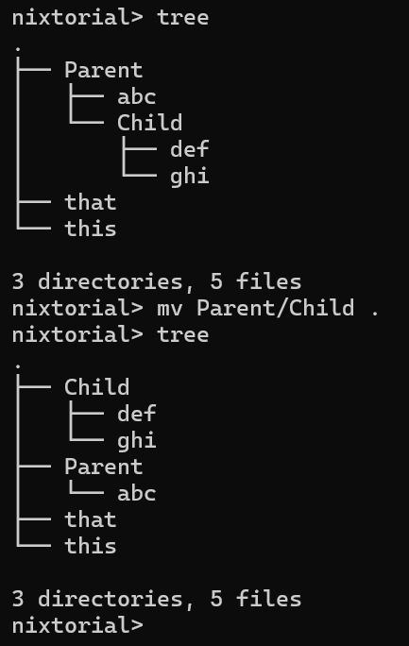

Grep command using a regular expression

For this lab I used the grep command using an RE or regular expression with special characters to specify a pattern or namelist for the name ‘Fred’ and ‘fred’. The characters used is not to have the command look for ‘Ffred’, the list matches one and only one character from those listed.

Example 1:
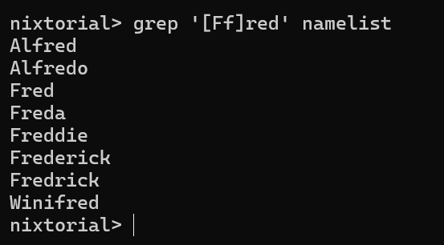

Example 2:
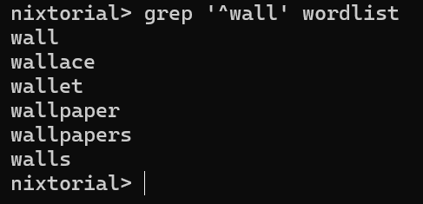

In this example, again, RE’s are used (special characters) to have the command look for ‘wall’.

Sed command using a delimiter:

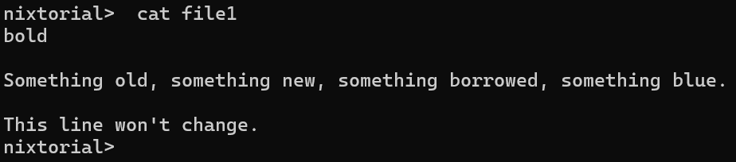

I ran the file ‘cat file1’ on the text interface.

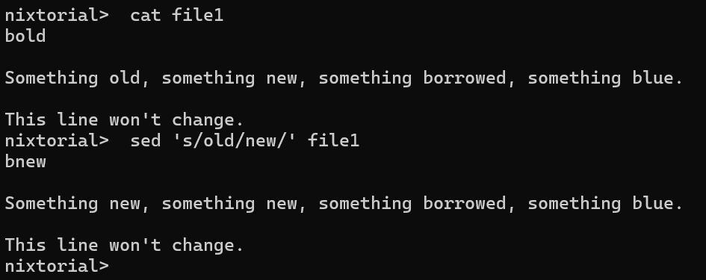

I input the sed command using ‘s’ as a substitute along with its required delimiter ‘/’ after each text. The sed command ‘s’ changed the first line from ‘something old’ to ‘something new’.

